**Day XX**

**13th September**

**Power BI:** A Visualization Tool.

Theoretical and other terminologies explained related to the Power BI.

**Blank starter template:**

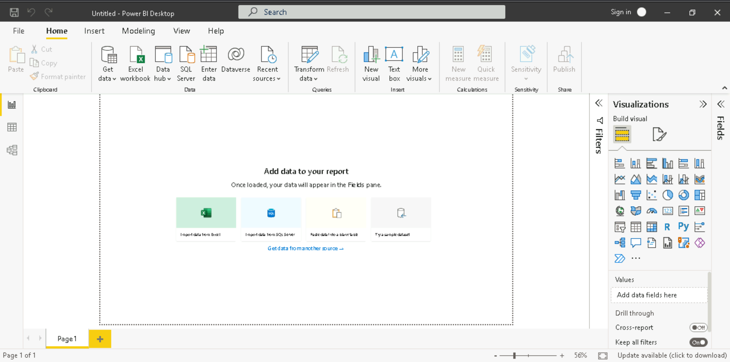

**Get Data** 🡪 Connecting with any desired supported service DB

**Excel Workbook** 🡪 Connecting Excel DB **Data Hub** 🡪 Connecting already existing Power BI

**Enter Data** 🡪 Manually entering for testing

**Reports:**

We can generate reports, i.e., visualize data in this section using different visualization tools like pi charts, bar charts, etc. A group of all these reports giving insights on different/individual features in a summarized form is called a **Dashboard**.

* Creating a basic Pi Chart: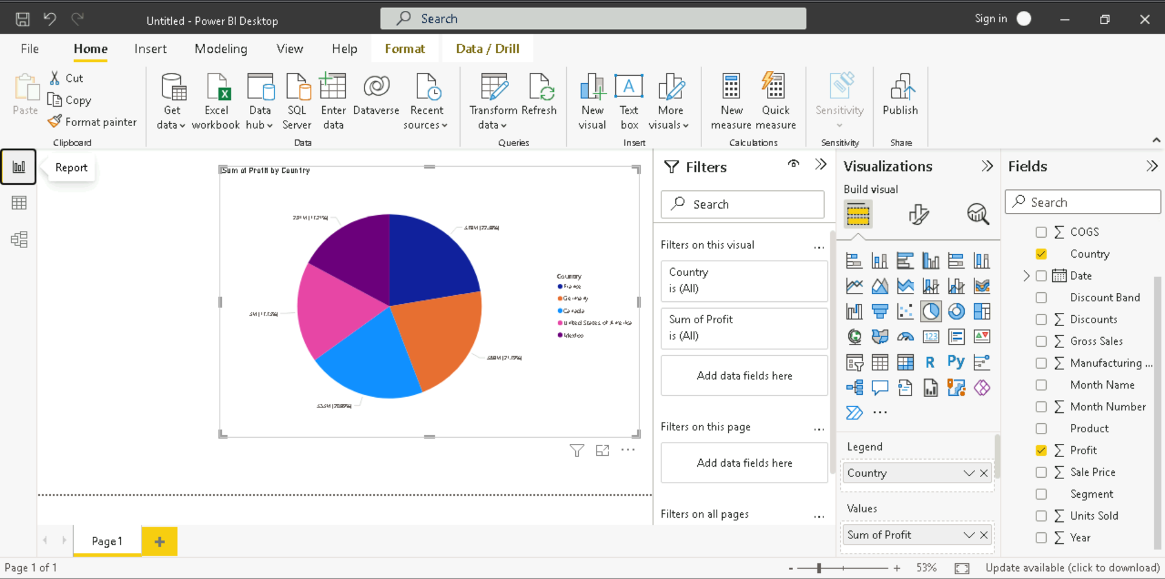
* Adding different tools and setting their properties which are visually pleasing (CSS)

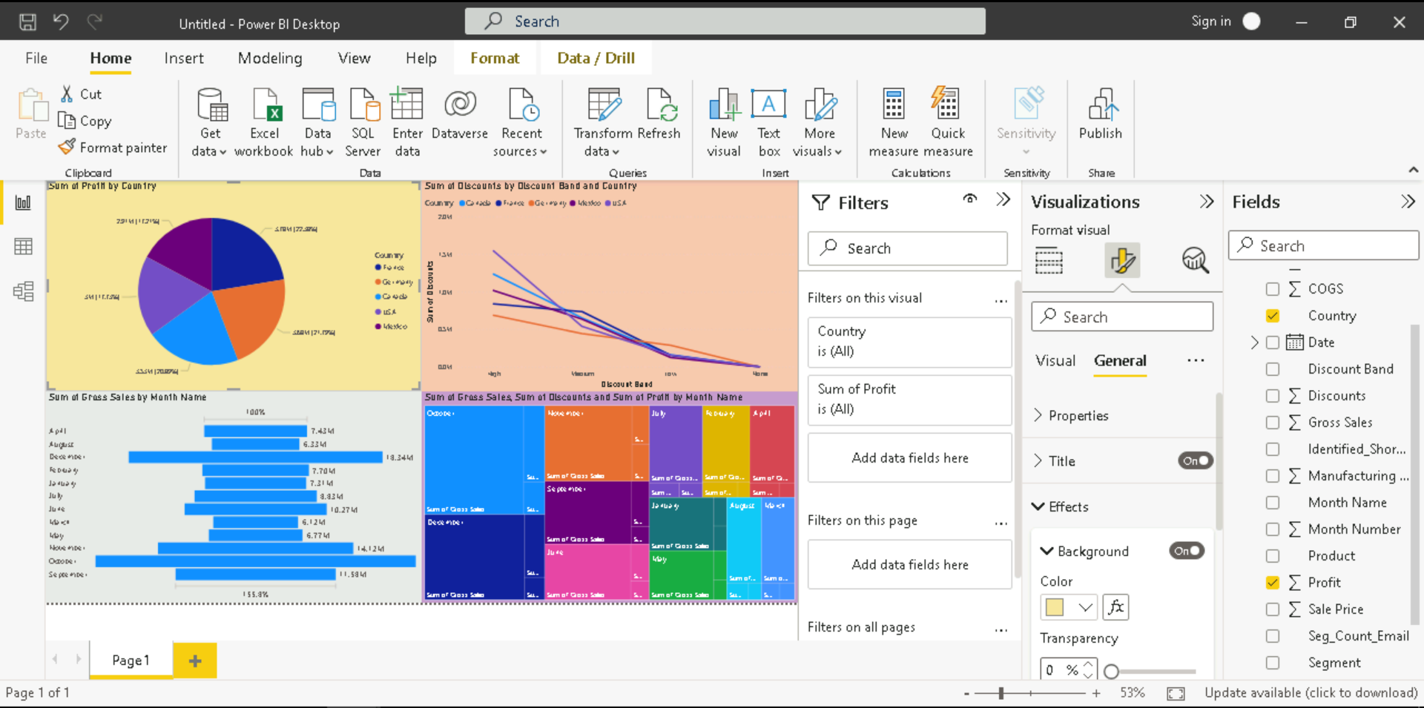

**Power Query Editor:**

**Transform Data** 🡪 Used for Data Transformation. The language behind this is **M language**, i.e., mashup query language. Data transformation is not very heavy in this tool, those tasks are done using Azure

* Replacing a value:

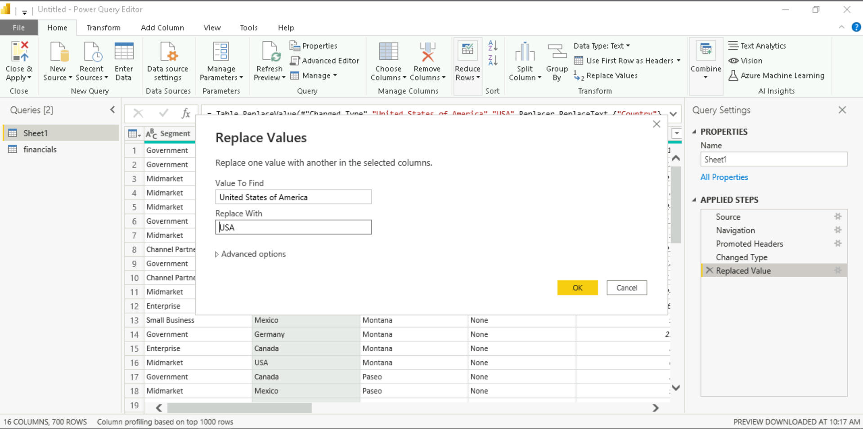

* Adding a custom column:

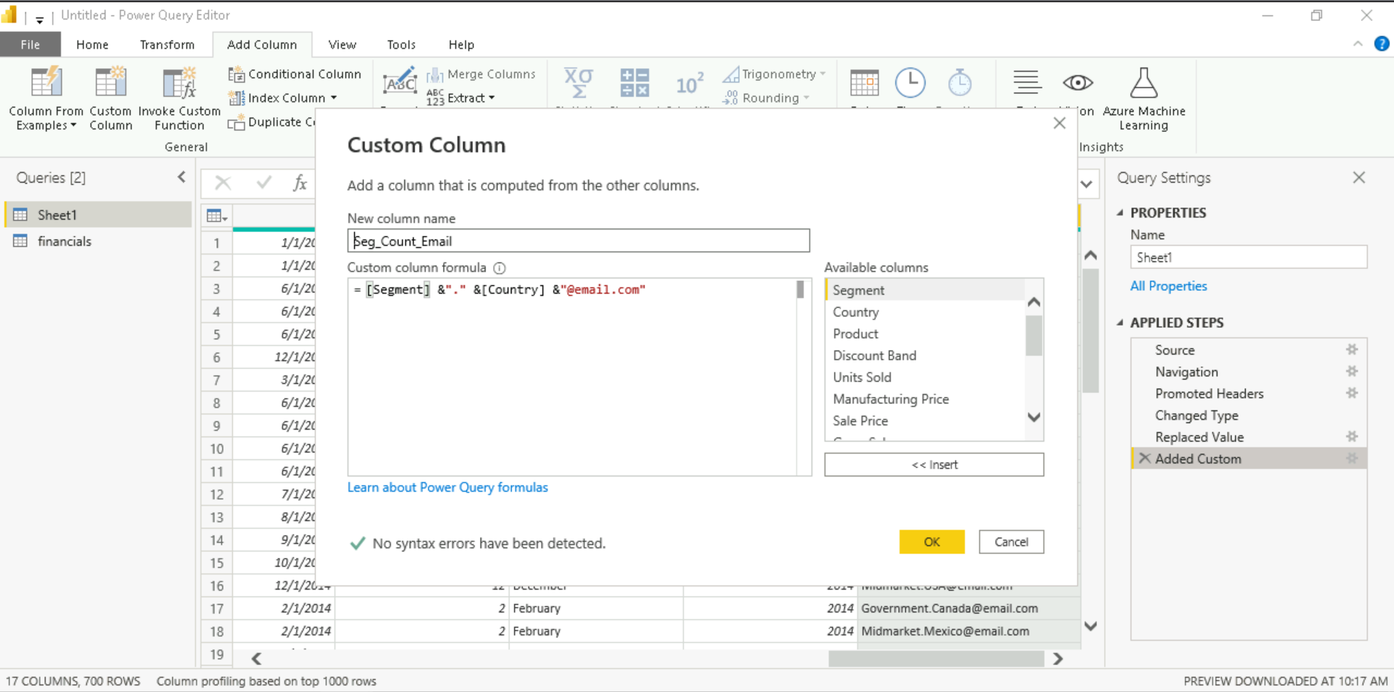

* Adding a conditional Column:

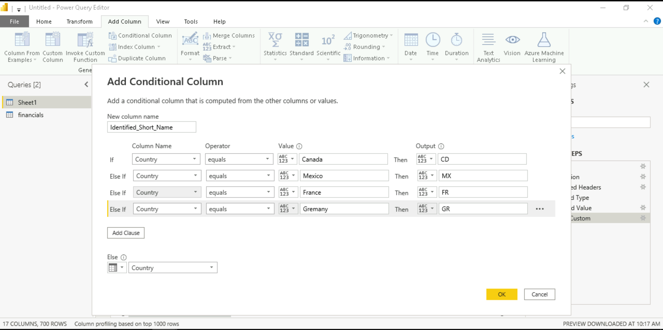 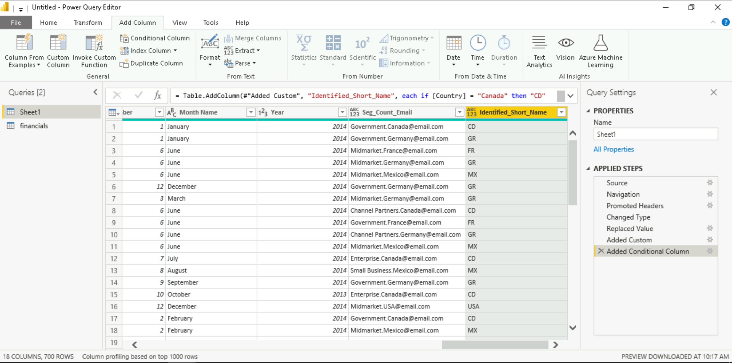

* Adding parameters example 🡪 Here the added parameter is the file location and in the advanced editor, the file path can be replaced with this parameter.

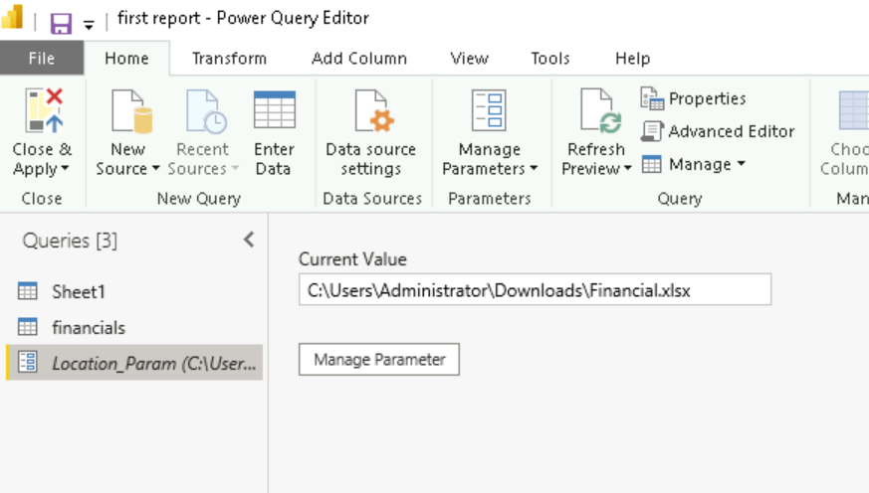 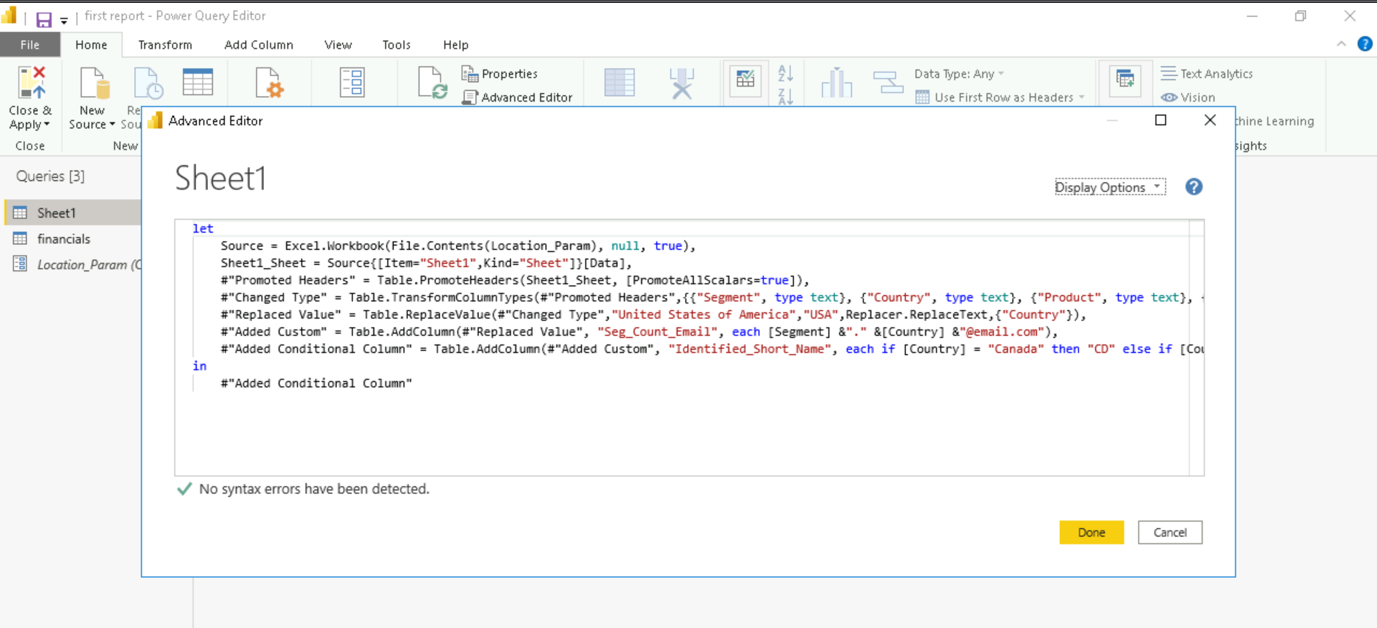

* 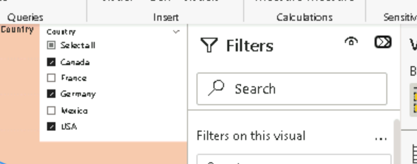Filter and Slice 🡪This is of three types, Visual (tool) wise, Page wise (All tools / visuals on the page) and Report wise (All the pages and tools / visuals ). This basically filters the data according to our need. We can add slice as an interractive feature or visual tool for the user to add a filter according to their need.
* 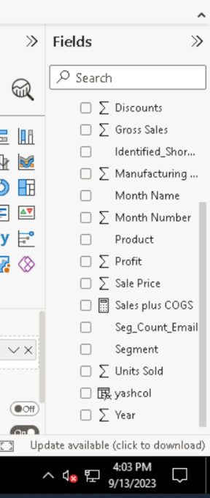Quick Measure 🡪 Calculated Columns create a new column in the table, i.e., the data that this column contains is also reflected in the table. Quick Measure is used to create run time measure which we can use in the power BI visual tools, but this does not actually create a new column, just a measure is created. Calculated Columns are created using M Language as mentioned earlier whereas Quick Measure is created using DAX Language which stands for Data Analytics Expression.
* Things missed 🡪 Manage Role 😊